Computational

Q2 A. Accuracy: 0.9777777777777777

Here, Preprocessing is done with StandardScaler() to convert similar scales like Converting variables into a format where machine learning algorithms can understand

Here data cleaning is not needed as from this wineData.isnull().sum() there are no null values

B.

1. 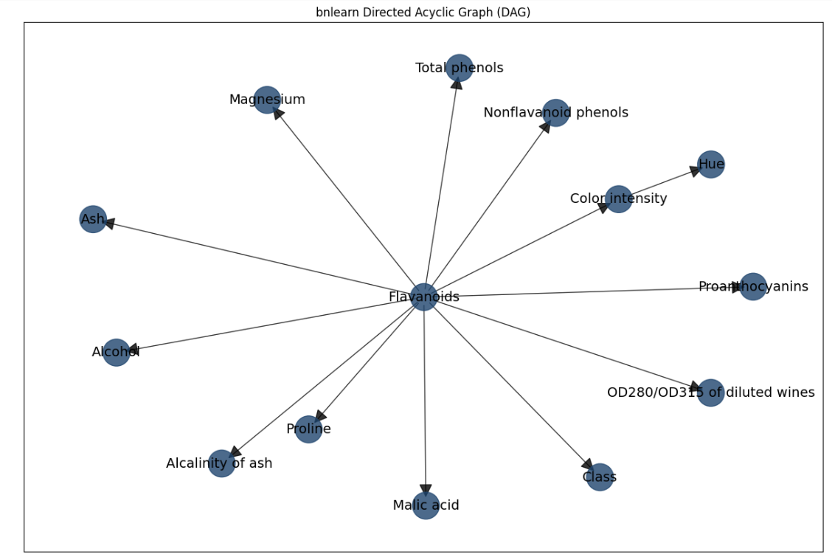

Here Parent is Flavanoid and it children are Ash Class etc.

Color Intensity is parent and child is hue

Accuracy is The accuracy of the model is: 0.8666666666666667

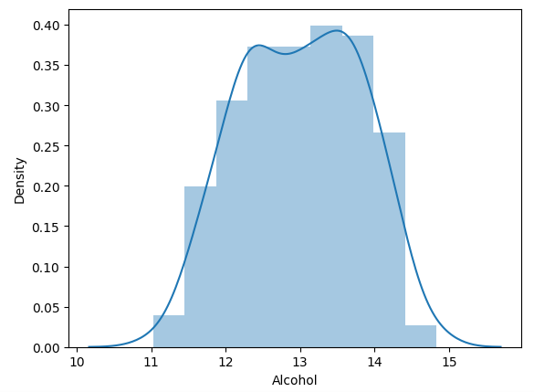

This visualizing the probability distribution.

2. 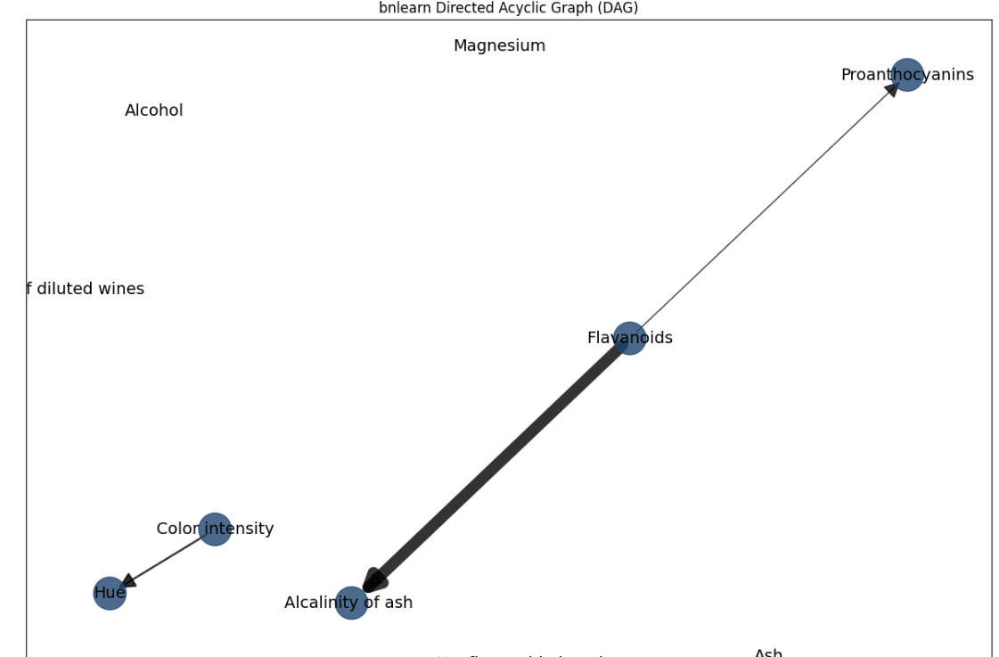

Network B

Accuracy is The accuracy of the model is: 0.9555555555555556

Probability Distribution

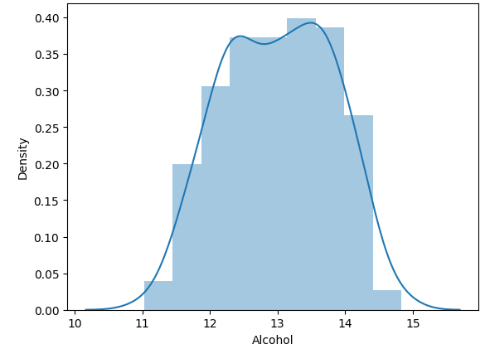

3. 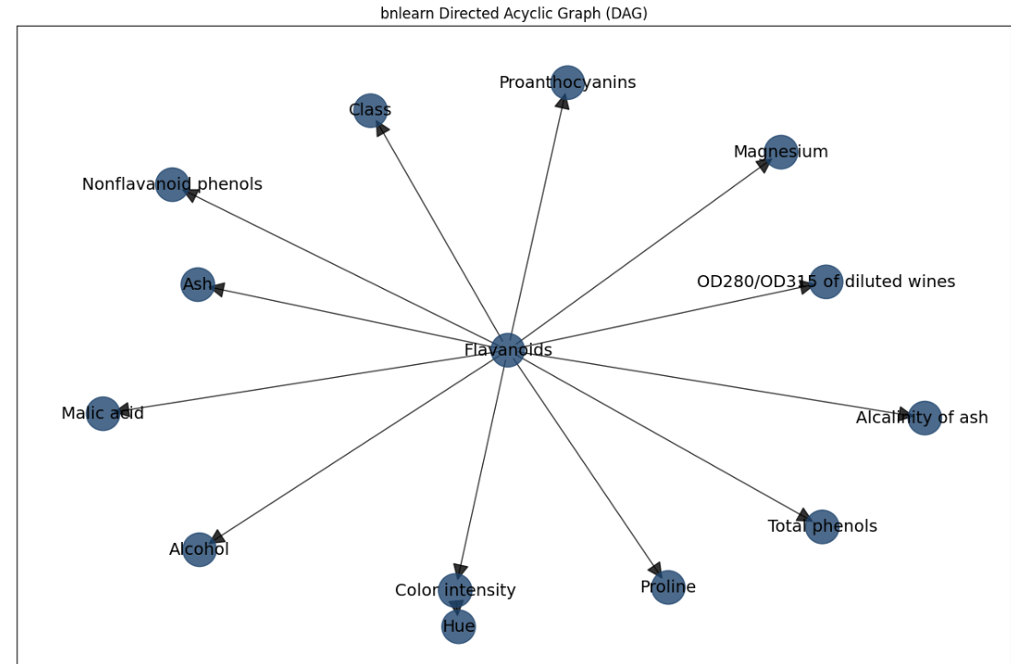

New Improved Network

Accuracy is The accuracy of the model is: 0.9555555555555556

Here I have used RandomForestClassifier for pruning for improving the network A by first making random state = 42 so that the result remains constant. And I have used RandomizedSearchCV for tuning the randomized search.

d.

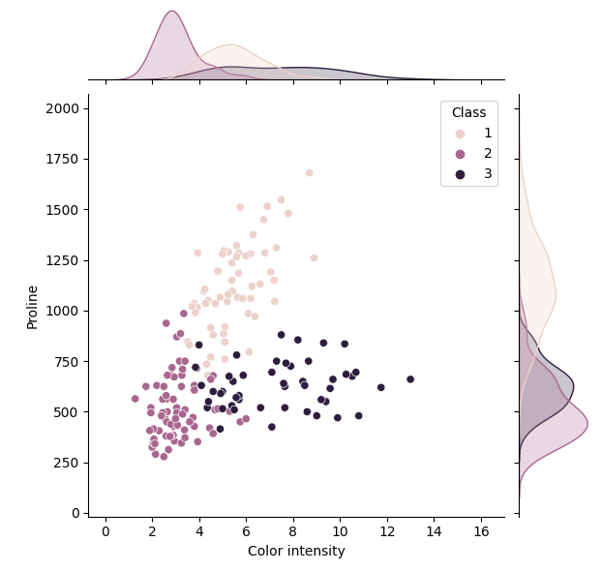

The change in probability distribution is different across these classes due to the different patterns of data point distribution. The underlying factors causing these differences could be numerous, ranging from inherent properties of the types, measurement techniques, or even random variation.

e. From all over, the values of posterior probabilities of variable(s) from all the network models predicted align well

with what I expected from the understanding of the data.